DO YOU KNOW CREEPING INDIGO?
LEARN THE DEADLY DIFFERENCE AND SAVE A LIFE!
Join us on FACEBOOK @ NINA’S WARRIORS and online
@www.ninaswarriors.com!
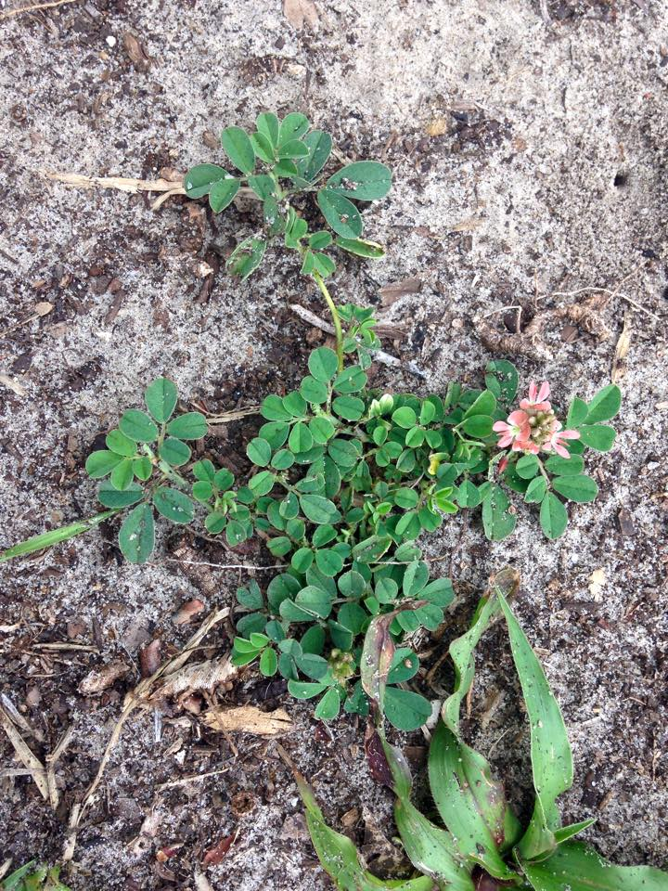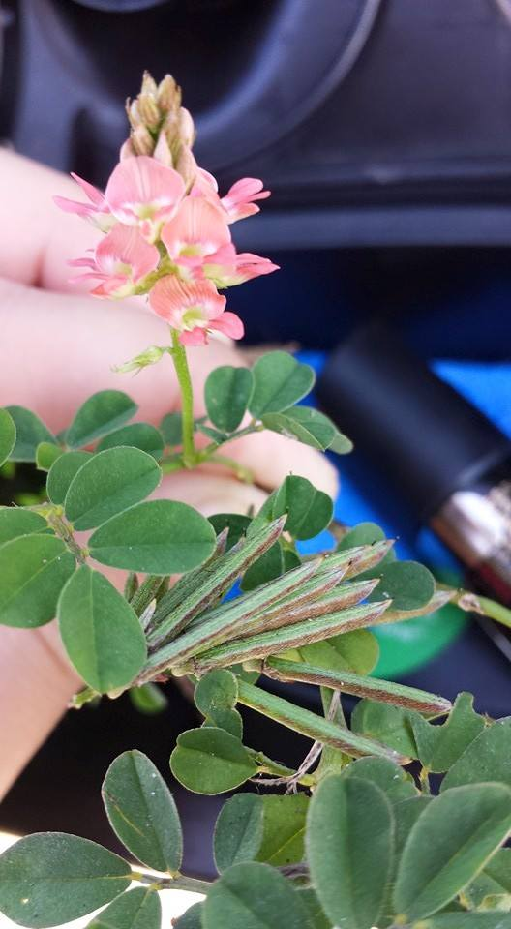

- TOXIC/DEADLY TO ALL ANIMALS AND THERE IS NO KNOWN CURE.
- Early diagnosis and removing the animal from the source of the plant is crucial.
- Symptoms vary per individual and include: depressed/stoned state, low carrying head, runny/gunky eyes, light sensitivity, weight loss, muscle atrophy, dropping feed, lack of coordination, off balance-stumbling, laminitis, seizures, droopy lips, ulcers on gums and corneas, rear kickstand/dead leg and abnormal gait.
- Neurological effects are largely irreversible.
- Toxicity spikes when the weed is stressed- i.e. cold snaps/drought/mowers.
- TASTES DELICIOUS to our animals and they will often choose it over grass and other vegetation even when forage/feed is plentifully provided.
- Ground cover vine, known to crawl beneath the grass making it difficult to spot.
- Vines and stems are pale green to yellow in color.
- Flowers are pink/coral and look like mini snap dragons reaching about 1in in length.
- Vines sprawl up to 6ft in length from ONE tap root that is firmly set & grows up to 3ft deep.
- Leaves alternate along stem. Each stem holds 5-9 leaflets.
- Leaves are green, have rounded tips and they taper slightly toward stem with one crease down the middle.

